S. No | Photo | Name | Designation | Qualification | Specialization | Contact | CV Link
1. | 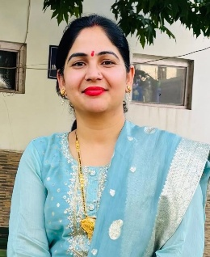 | Dr. Arti Sharma | Assistant Professor | Ph.D. | Sustainable Sericulture Practices, Silkworm Crop Productivity and Yield Optimization | Email: artiattusharma@gmail.com  Mobile: 7889573448
2. | 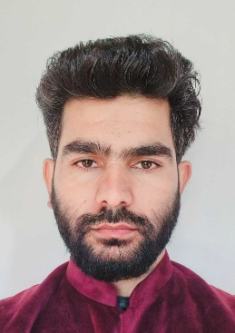 | Dr. Aadil Hussain Mir | Lecturer  (Contractual) | Ph.D. | Moriculture and Silkworm Rearing | Email: aadilmir39@gmail.com  Mobile: 9906667003

Name of the Department: Sericulture
Teaching Faculty

Non-Teaching & MTS Staff
S. No | Photo | Name | Designation
1. | 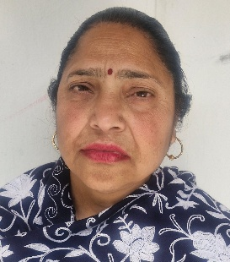 | Ms. Gurmeet Kour | Laboratory Assistant
2. |  | Mr. Imtiaz Ahmed | Local Fund Employee

